INTRODUCTION TO JAVA2

//1. Create Java classes having suitable attributes for Library management system.
// Use OOPs concepts in your design.Also try to use interfaces and abstract classes.
package Ques1;
public class Library extends Person {
public static void main(String[] args) {
Person p1=new Person();
p1.Name="Gunjan Dawar";
System.out.println("Student Name :"+p1.Name+"\nBook_name: "+p1.bookName("The Fault In Our Stars")+"\nAuthor Name: "+p1.authorName("John Michael Green "));
System.out.println("Issued on : "+p1.issue_on("3-feb-2020")+" till "+p1.issue_till("7")+" days.");
}
}

package Ques1;
public class Person implements Book,IssuedOn {
String Name;
@Override
public String bookName(String bn) {
return bn;
}
@Override
public String authorName(String an) {
return an;
}
@Override
public String issue_on(String In) {
return In;
}
@Override
public String issue_till(String It) {
return It;
}
}
package Ques1;
public interface IssuedOn {
String issue_on(String In);
String issue_till(String It);
}
package Ques1;
public interface Book {
String bookName(String bn);
String authorName(String an);
}
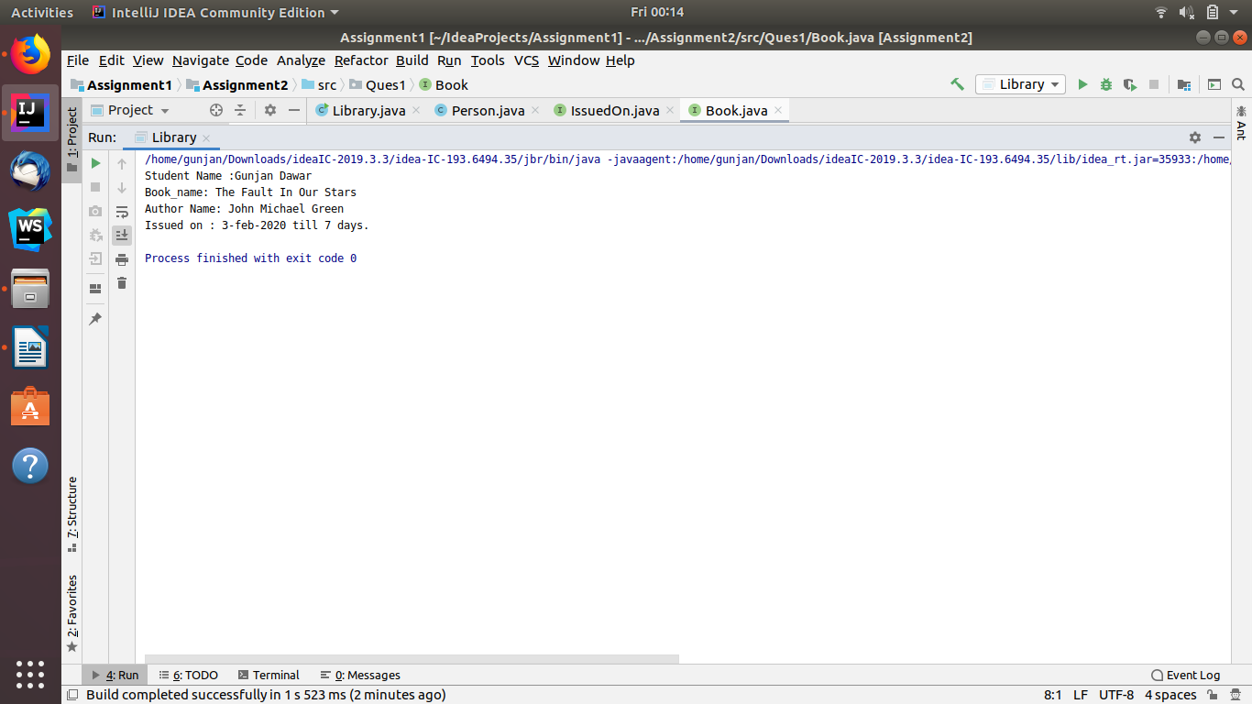

//2. WAP to sorting string without using string Methods?.
import java.util.Arrays;
public class Ques2 {
public static void main(String[] args)
{
String str = "cdba";
char arr[] = str.toCharArray();
for (int i = 0; i < arr.length; i++)
{
for (int j = i+1; j < arr.length; j++)
{
if (arr[i] > arr[j])
{
char temp = arr[i];
arr[i] = arr[j];
arr[j] = temp;
}
}
}
for (int i = 0; i < arr.length; i++)
{
System.out.println(arr[i]);
}
}
}
// public static void main(String[] args) {
// String str = "dcba";
// char arr[] = str.toCharArray();
// Arrays.sort(arr);
// String output = new String(arr);
// System.out.println(output);
// }

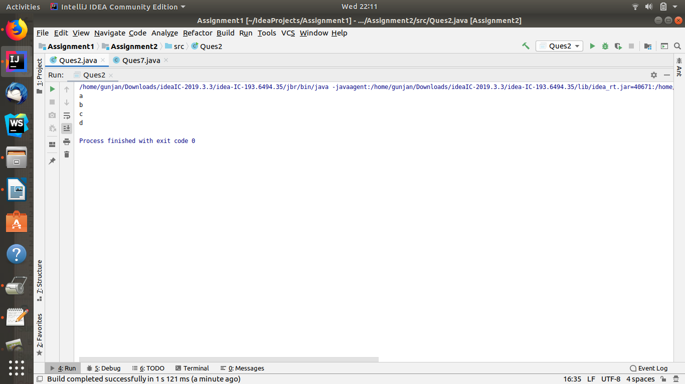

//3. WAP to produce NoClassDefFoundError and ClassNotFoundException exception.
//ClassNotFoundException is an exception that occurs when you try to load a class at run time using Class.forName() or loadClass() methods and mentioned classes are not found in the classpath.
// NoClassDefFoundError is an error that occurs when a particular class is present at compile time, but was missing at run time.
public class Ques3 {
public static void main(String[] args) {
Q3_a q = new Q3_a();
q.hello();
try
{
Class.forName("Ques14");
}
catch(ClassNotFoundException ex)
{
ex.printStackTrace();
}
}
}
class Q3_a {
//If this class is deleted now the it will give NoClassDefFoundError.......
void hello()
{
System.out.println("This is a class");
}
}
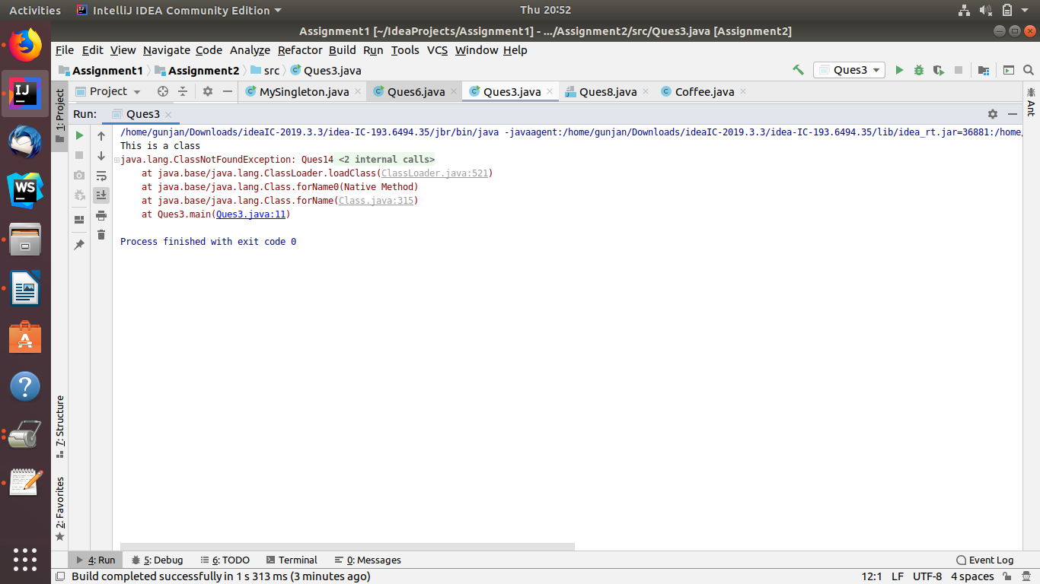
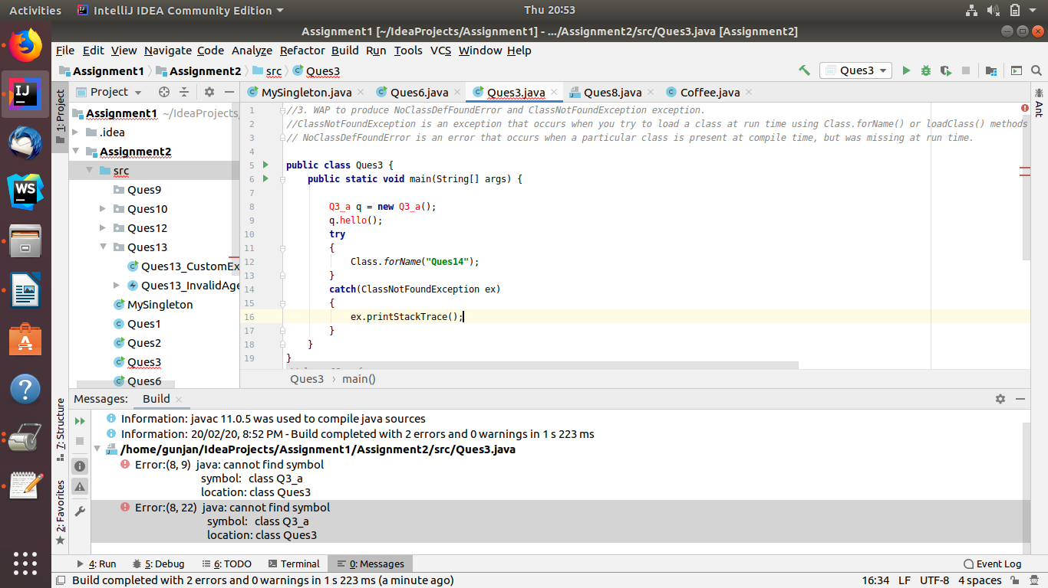

//4. WAP to create singleton class.
//Singleton class means you can create only one object for the given class.
// You can create a singleton class by making its constructor as private, so that you can restrict the creation of the object.
// Provide a static method to get instance of the object,
//wherein you can handle the object creation inside the class only.
//Singleton Class
public class Ques4_Singleton {
private static Ques4_Singleton myObj=new Ques4_Singleton();
private Ques4_Singleton(){
}
public static Ques4_Singleton getInstance(){
return myObj;
}
public void testMe(){
System.out.println("Hey,Welcome to Java");
}
public static void main(String a[]){
Ques4_Singleton x = getInstance();
Ques4_Singleton y = getInstance();
x.testMe();
y.testMe();
}
}
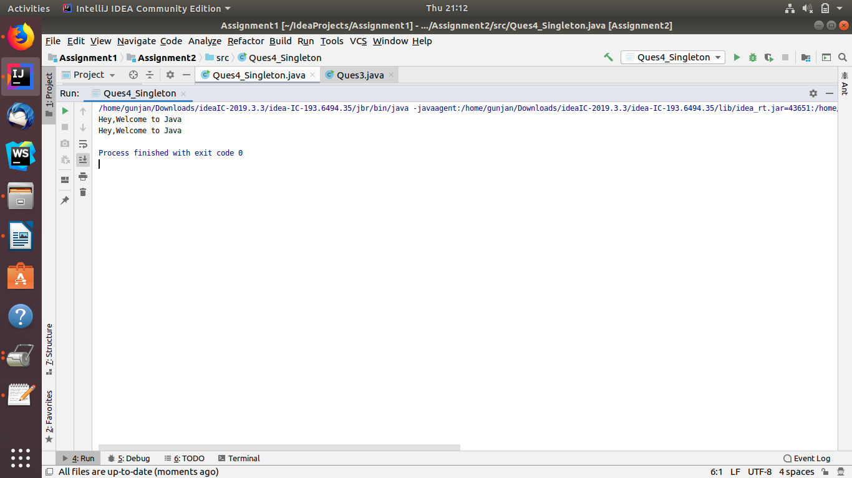

//5. WAP to show object cloning in java using cloneable and copy constructor both.
public class Ques5 {
public static void main(String[] args) throws CloneNotSupportedException {
Stud obj = new Stud("Gunjan");
Stud obj2 = new Stud(obj);
System.out.println(obj2.Name);
tryingClone tc = new tryingClone();
tc.name = "Dawar";
tryingClone tc1 = (tryingClone) tc.clone();
System.out.println(tc1.name.toString());
}
}
class Stud {{
}
String Name;
public Stud(String f)
{
this.Name = f;
}
public Stud(Stud obj)
{
Name = obj.Name;
}
}
// Name = obj.Name;
// }
class tryingClone implements Cloneable {
String name;
@Override
public Object clone() throws CloneNotSupportedException{
return super.clone();
}
}
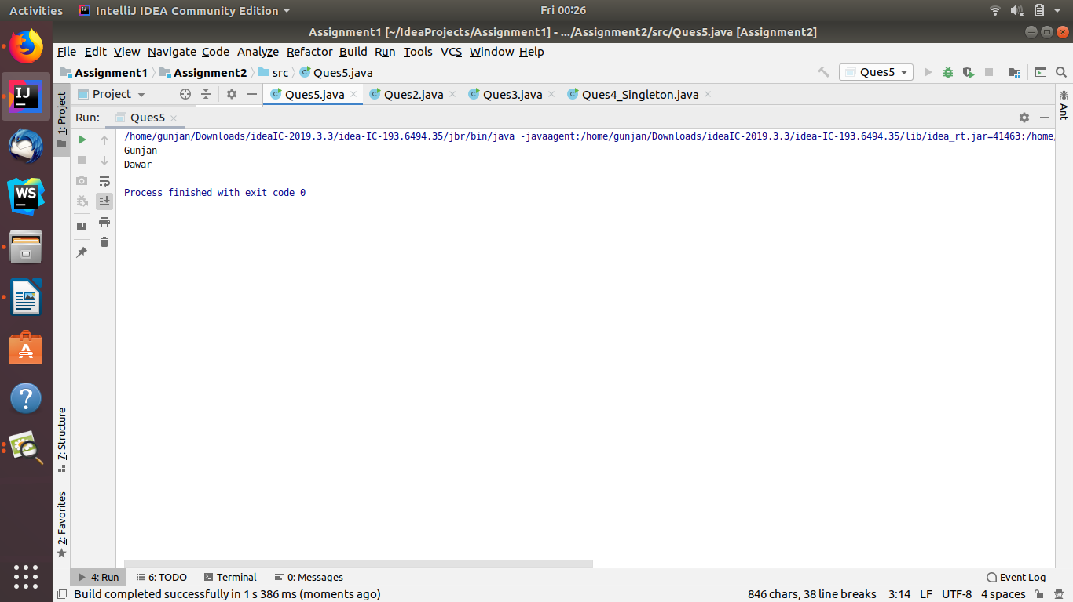

//6. WAP showing try, multi-catch and finally blocks.
public class Ques6 {
public static void main(String[] args)throws ArithmeticException,ArrayIndexOutOfBoundsException {
int a[]={1,2,3,4};
try
{
int A=0;
int B=5;
//int C =B/A;
for(int i=0; i<9;i++)
{
System.out.println(a[i]);
}
}
catch (ArrayIndexOutOfBoundsException e)
{
System.out.println(e);
}
catch(ArithmeticException a1)
{
System.out.println(a1);
}
catch(Exception e1){
System.out.println(e1);
}
finally{
System.out.println("Execution is over");
}
}
}
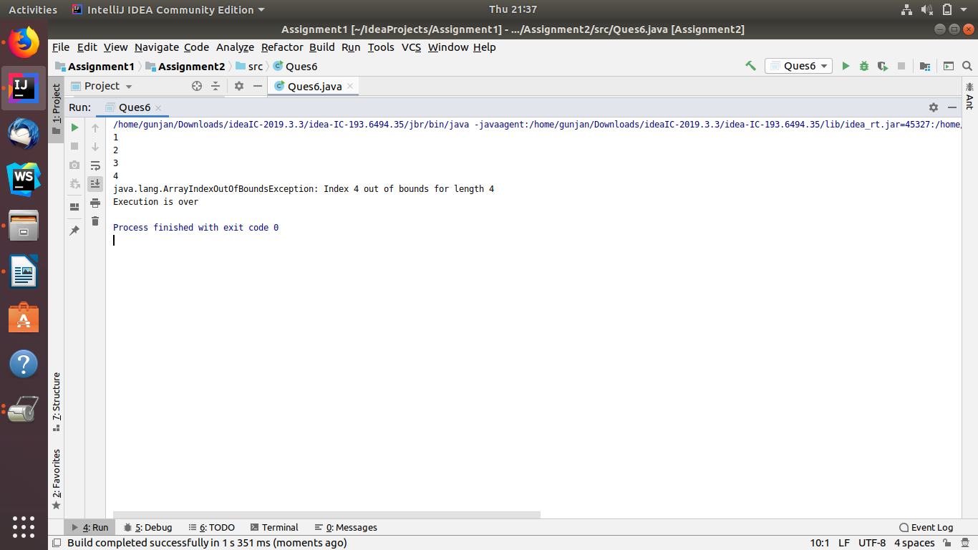

//7. WAP to convert seconds into days, hours, minutes and seconds.
public class Ques7 {
public static void main (String[] args)
{
int n = 129600;
Convert(n);
}
static void Convert(int n)
{
int day = n / (24 * 3600);
n = n % (24 * 3600);
int hour = n / 3600;
n %= 3600;
int minutes = n / 60 ;
n %= 60;
int seconds = n;
System.out.println( day + " " + "days " + hour + " " + "hours " + minutes + " " + "minutes " + seconds + " " + "seconds ");
}
}
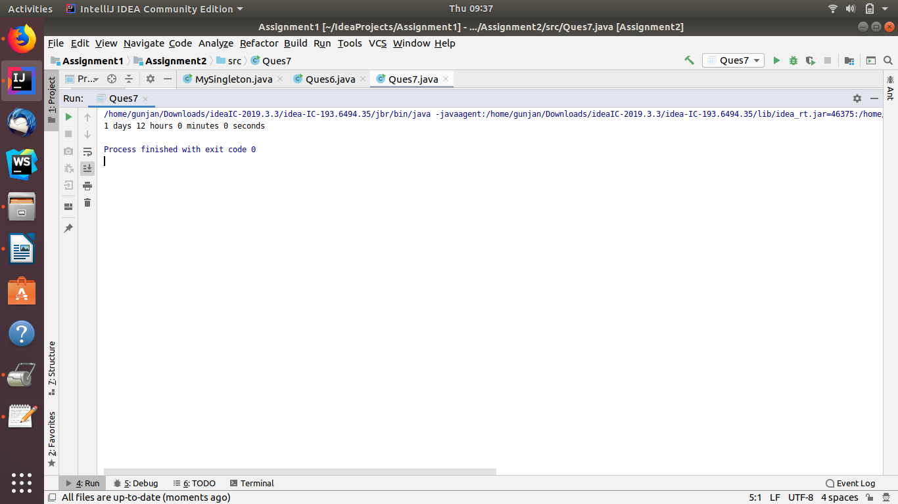

//8. WAP to read words from the keyboard until the word done is entered.
// For each word except done, report whether its first character is equal to its last character. For the required loop, use a
//a)while statement
//b)do-while statement
import java.util.Scanner;
public class Ques8 {
public static void main(String[] args) {
String words;
Scanner sc=new Scanner(System.in);
System.out.println("Enter the words:");
while(true){
words=sc.nextLine();
if(words.equalsIgnoreCase("done"))
break;
else{
String[] arr = words.split("");
if (arr[0].equalsIgnoreCase(arr[arr.length - 1]))
System.out.println("First and last char of " + words + " is matched.");
else
System.out.println("First and last char of " + words + " is not matched.");
}
}
withdowhile();
}
static void withdowhile(){
System.out.println("--------------------------------");
System.out.println("Enter words again for do while loop...");
Scanner s1 = new Scanner(System.in);
String words1;
do {
words1 = s1.nextLine();
if (words1.equalsIgnoreCase("done"))
break;
else {
String[] arr = words1.split("");
if (arr[0].equalsIgnoreCase(arr[arr.length - 1]))
System.out.println("First and last char of " + words1 + " is matched.");
else
System.out.println("First and last char of " + words1 + " is not matched.");
}
}
while (true);
}
}
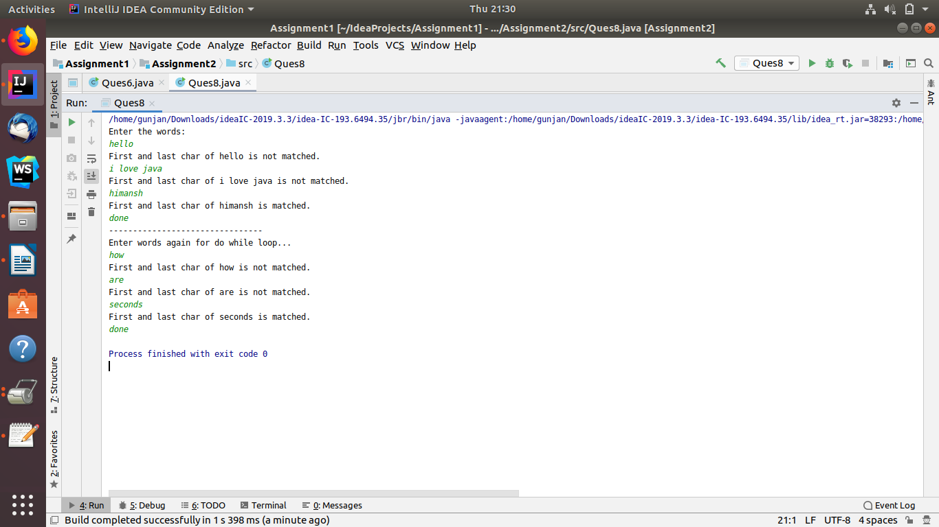

//9. Design classes having attributes for furniture where there are wooden chairs and tables, metal chairs and tables.
// There are stress and fire tests for each products.
package Ques9;
public class Ques9_a {
public static void main(String[] args) {
Ques9_chair ch = new Ques9_chair("wooden", true, true);
Ques9_table tb = new Ques9_table("metal", true, true);
System.out.println("For CHAIR--");
System.out.println("Type is: "+ch.type);
System.out.println("Stress test : "+ch.checkStress());
System.out.println("Fire test : "+ch.checkfire());
System.out.println("*********************************");
System.out.println("For TABLE--");
System.out.println("Type is: "+tb.type);
System.out.println("Stress test: "+tb.checkfire());
System.out.println("Fire test: "+tb.checkStress());
}
}
package Ques9;
public abstract class Ques9_furniture {
public abstract boolean checkStress();
public abstract boolean checkfire();
}

package Ques9;
public class Ques9_table extends Ques9_furniture{
String type;
boolean fire;
boolean stress;
public String getType() {
return type;
}
public Ques9_table(String t, boolean f, boolean s)
{
this.type=t;
this.fire=f;
this.stress=s;
}
public boolean isFire() {
return fire;
}
public boolean isStress() {
return stress;
}
@Override
public boolean checkStress()
{
return stress;
}
@Override
public boolean checkfire() {
return fire;
}
}
package Ques9;
public class Ques9_chair extends Ques9_furniture{
String type;
boolean fire;
boolean stress;
public String getType() {
return type;
}
public Ques9_chair(String t, boolean f, boolean s)
{
this.type=t;
this.fire=f;
this.stress=s;
}
public boolean isFire() {
return fire;
}
public boolean isStress() {
return stress;
}
@Override
public boolean checkStress()
{
return stress;
}
@Override
public boolean checkfire() {
return fire;
}
}
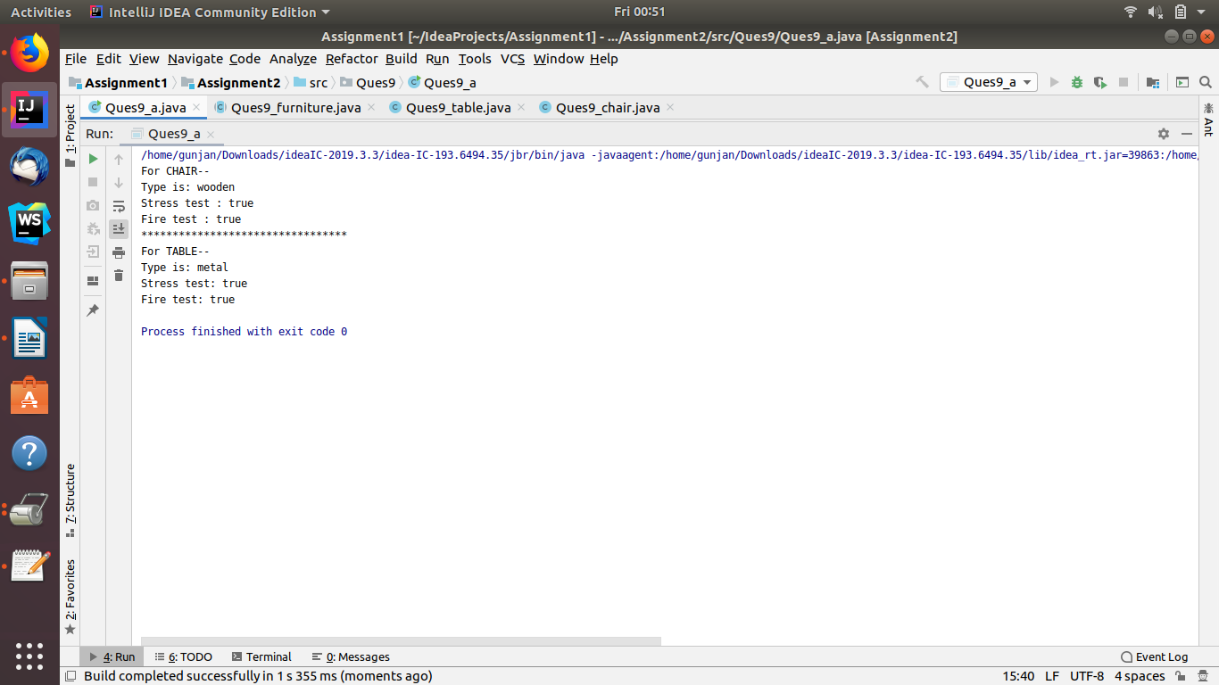

//10. Design classes having attributes and method(only skeleton) for a coffee shop. There are three different actors in our scenario and i have listed the different actions they do also below
//
// * Customer
// - Pays the cash to the cashier and places his order, get a token number back
// - Waits for the intimation that order for his token is ready
// - Upon intimation/notification he collects the coffee and enjoys his drink
// ( Assumption: Customer waits till the coffee is done, he wont timeout and cancel the order. Customer always likes the drink served. Exceptions like he not liking his coffee, he getting wrong coffee are not considered to keep the design simple.)
//
// * Cashier
// - Takes an order and payment from the customer
// - Upon payment, creates an order and places it into the order queue
// - Intimates the customer that he has to wait for his token and gives him his token
// ( Assumption: Token returned to the customer is the order id. Order queue is unlimited. With a simple modification, we can design for a limited queue size)
//
// * Barista
// - Gets the next order from the queue
// - Prepares the coffee
// - Places the coffee in the completed order queue
// - Places a notification that order for token is ready

package Ques10;
import java.util.Scanner;
public class Ques10_customer extends Ques10_cashier{
public static String order;
public static String name;
public static void main(String[] args) {
Scanner s =new Scanner(System.in);
System.out.println("Enter your name please !");
name = s.nextLine();
cust();
}
public static void cust() {
Ques10.Ques10_customer c=new Ques10.Ques10_customer();
System.out.println("Hello "+name+" !!! Wants a coffee? y/n");
Scanner sc =new Scanner(System.in);
order = sc.nextLine();
if(order.equalsIgnoreCase("y"))
c.payment();
else
System.out.println("Kindly Order something !!! Thank You...");
}
void payment(){
Ques10_customer c=new Ques10_customer();
Ques10_cashier.add(c.order);
}
static void ready(){
System.out.println("We are happy to serve you, Collect your Order. \n Thank You... :)");
}
}

package Ques10;
import java.util.LinkedList;
import java.util.Queue;
public class Ques10_cashier {
public static Queue<String> Q=new LinkedList<>();
static void add(String coffee) {
Q.add(coffee);
System.out.println("Order placed !, Your Order no. is : " + Q.size());
Ques10_Barista.prepration();
}
}

package Ques10;
public class Ques10_Barista {
public static void prepration() {
System.out.println("Please wait until your Order gets ready...");
try {
Thread.sleep(10000);
} catch (InterruptedException e) {
e.printStackTrace();
}
System.out.println("Order is ready...");
Ques10_cashier.Q.remove();
Ques10_customer.ready();
}
}

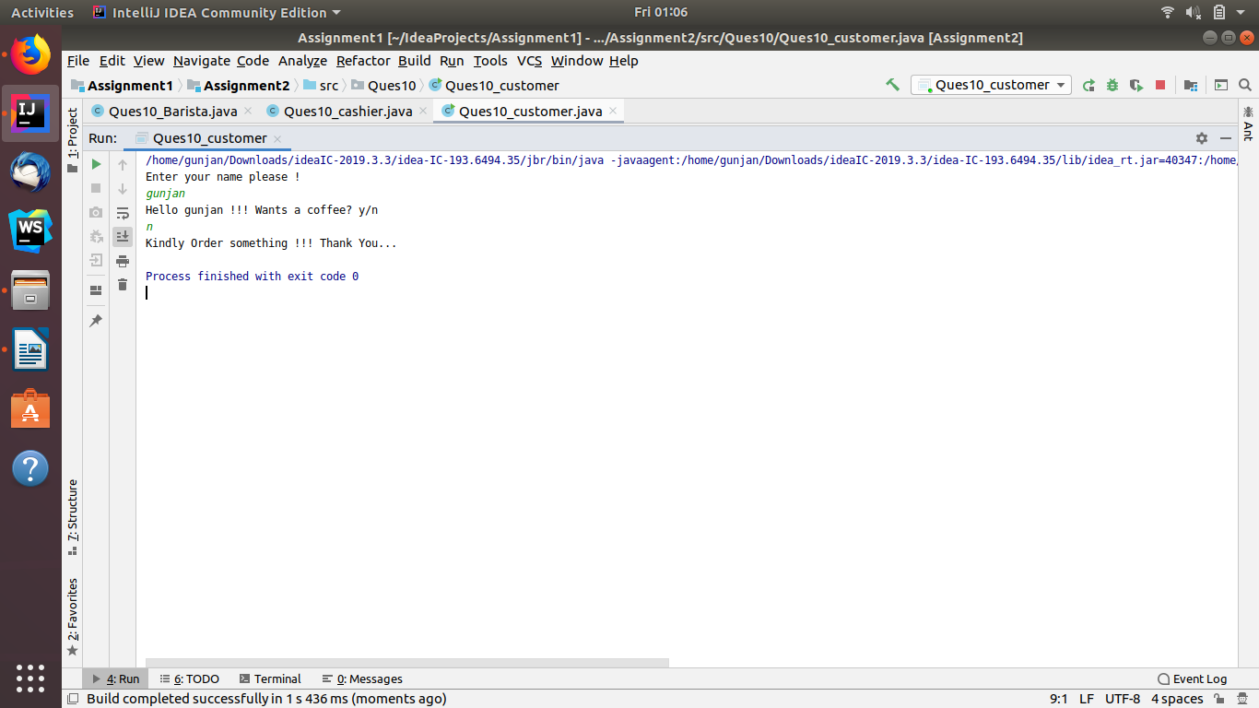

//11. Convert the following code so that it uses nested while statements instead of for statements:
// int s = 0;
// int t = 1;
// for (int i = 0; i < 10; i++)
// {
// s = s + i;
// for (int j = i; j > 0; j−−)
// {
// t = t * (j - i);
// }
// s = s * t;
// System.out.println("T is " + t);
// }
// System.out.println("S is " + s);
//OUTPUT: T is 1
// T is 0
// T is 0
// T is 0
// T is 0
// T is 0
// T is 0
// T is 0
// T is 0
// T is 0
// S is 0

public class Ques11 {
public static void main(String[] args) {
int i=0;
int s = 0;
int t = 1;
while(i<10)
{
s = s + i;
int j=i;
while(j>0)
{
t = t * (j - i);
j--;
}
s = s * t;
System.out.println("T is " + t);
i++;
}
System.out.println("S is " + s);
}
}
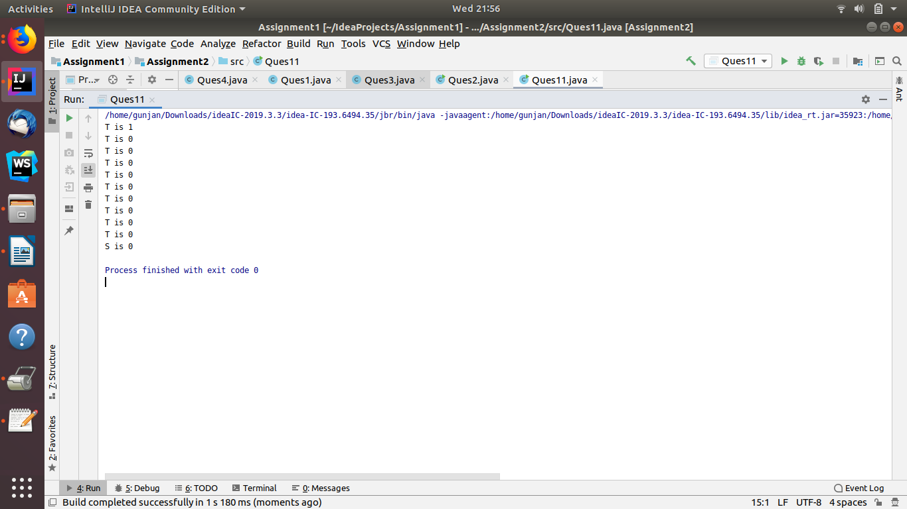

//12.What will be the output on new Child(); ?
//class Parent extends Grandparent {
//
// {
// System.out.println("instance - parent");
// }
//
// public Parent() {
// System.out.println("constructor - parent");
// }
//
// static {
// System.out.println("static - parent");
// }
//}
//
//class Grandparent {
//
// static {
// System.out.println("static - grandparent");
// }
//
// {
// System.out.println("instance - grandparent");
// }
//
// public Grandparent() {
// System.out.println("constructor - grandparent");
// }
//}
//
//class Child extends Parent {
//
// public Child() {
// System.out.println("constructor - child");
// }
//
// static {
// System.out.println("static - child");
// }
//
// {
// System.out.println("instance - child");
// }
//}
package Ques12;
public class Main {
public static void main(String[] args) {
Child c = new Child();
}
}

package Ques12;
public class Parent extends Grandparent {
{
System.out.println("instance - parent");
}
public Parent() {
System.out.println("constructor - parent");
}
static {
System.out.println("static - parent");
}
}

package Ques12;
public class Grandparent {
static {
System.out.println("static - grandparent");
}
{
System.out.println("instance - grandparent");
}
public Grandparent() {
System.out.println("constructor - grandparent");
}
}

package Ques12;
public class Child extends Parent {
public Child() {
System.out.println("constructor - child");
}
static {
System.out.println("static - child");
}
{
System.out.println("instance - child");
}
}

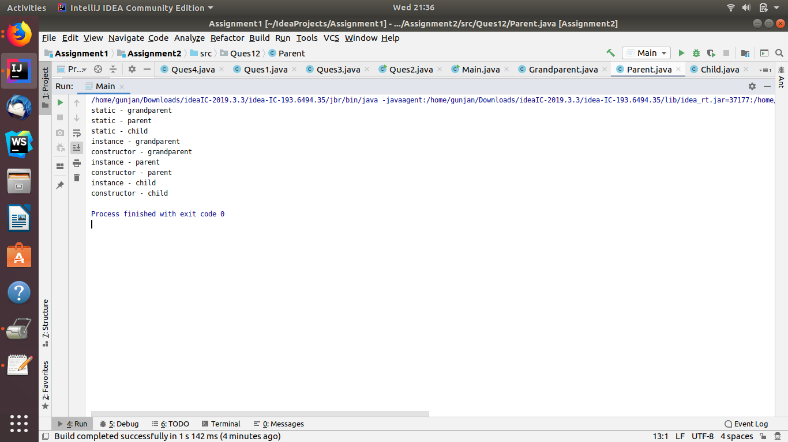

//Q13. Create a custom exception that do not have any stack trace.
package Ques13;
class Ques13_CustomException{
static void validate(int age) throws InvalidAgeException{
if(age<18)
throw new InvalidAgeException(" Not valid");
else
System.out.println("Eligible to vote ");
}
public static void main(String args[]){
try{
validate(12);
}
catch(Exception e){
System.out.println("Exception occured: "+e);
}
}
}

package Ques13;
class InvalidAgeException extends Exception{
InvalidAgeException(String s){
super(s);
System.out.println("Custom Exception occured");
}
}
